Windshield Research
Edwin Mathew
The benefits of a windshield for a car
Just like sunscreen, the windshield of any car can shield/protect you from sun’s UV rays, which can be very harmful for the human body. Thanks to the laminated glass that, is contrasted in the modern cars, the windshield is a formidable force protection. Furthermore, the windshield plays an essential role in keeping the coolness of a car interior. It takes on a combination of absorptive and reflective properties to deflect the sunlight, thus reducing the heat buildup inside the car effectively. Another benefit of a windshield is, in an accident the windshield acts as a safety cover for the people in the car and a vital component on keeping the structural integrity of the car, as it distributes the force of impact, preventing the roof from collapsing and dangerous shards of glass going everywhere. The wind shield can contribute to the car’s aerodynamics, as it can reduce drag helping the car to work more efficiently.

How are we going to use a windscreen for our RC Car?
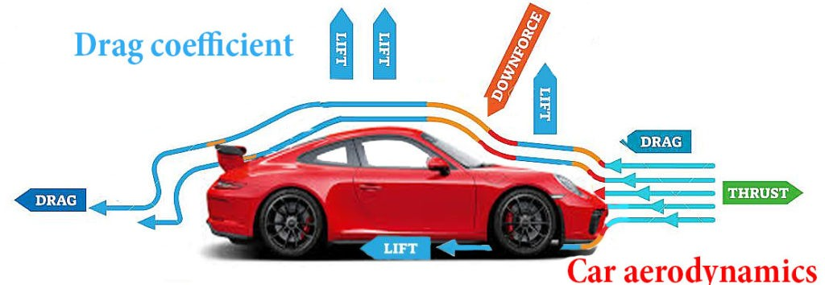
The servo of our RC Trophy Truck is heating up without it been driven for that long. At the moment the truck does not have a windshield, so the wind is just going in through the front and then going out the back. It is not hitting the servo enough to cool it down. To prevent this the group has decided to build a roof scoup to guide the scoup to hit and cool down the servo. Along with this we decided to try and add a windshield so the wind will follow the slop and go into the roof scoop, thus allowing even more wind flow hitting the servo to cool it down.
References
Fairfield AutoGlass, 8 BENEFITS OF WINDSCREEN ON YOUR CAR,
https://www.fairfieldautoglass.com.au/8-benefits-of-windscreen-on-your-car

